# CS 255 System Design Document

**By Thomas Fiske**

**8/14/2022**

## UML Diagrams

### UML Use Case Diagram

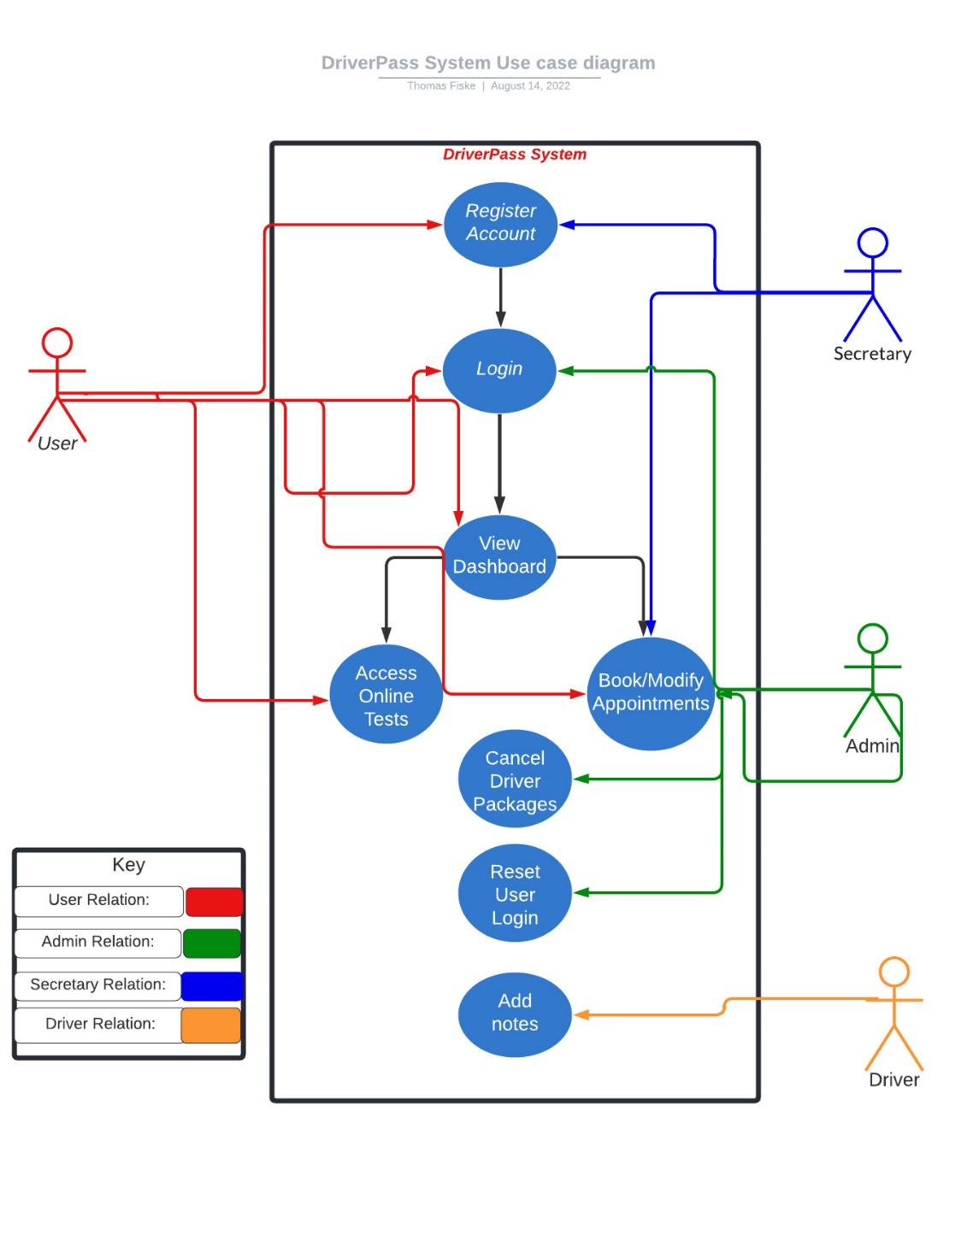

### UML Activity Diagrams

### 

### 

### UML Sequence Diagram

### UML Class Diagram

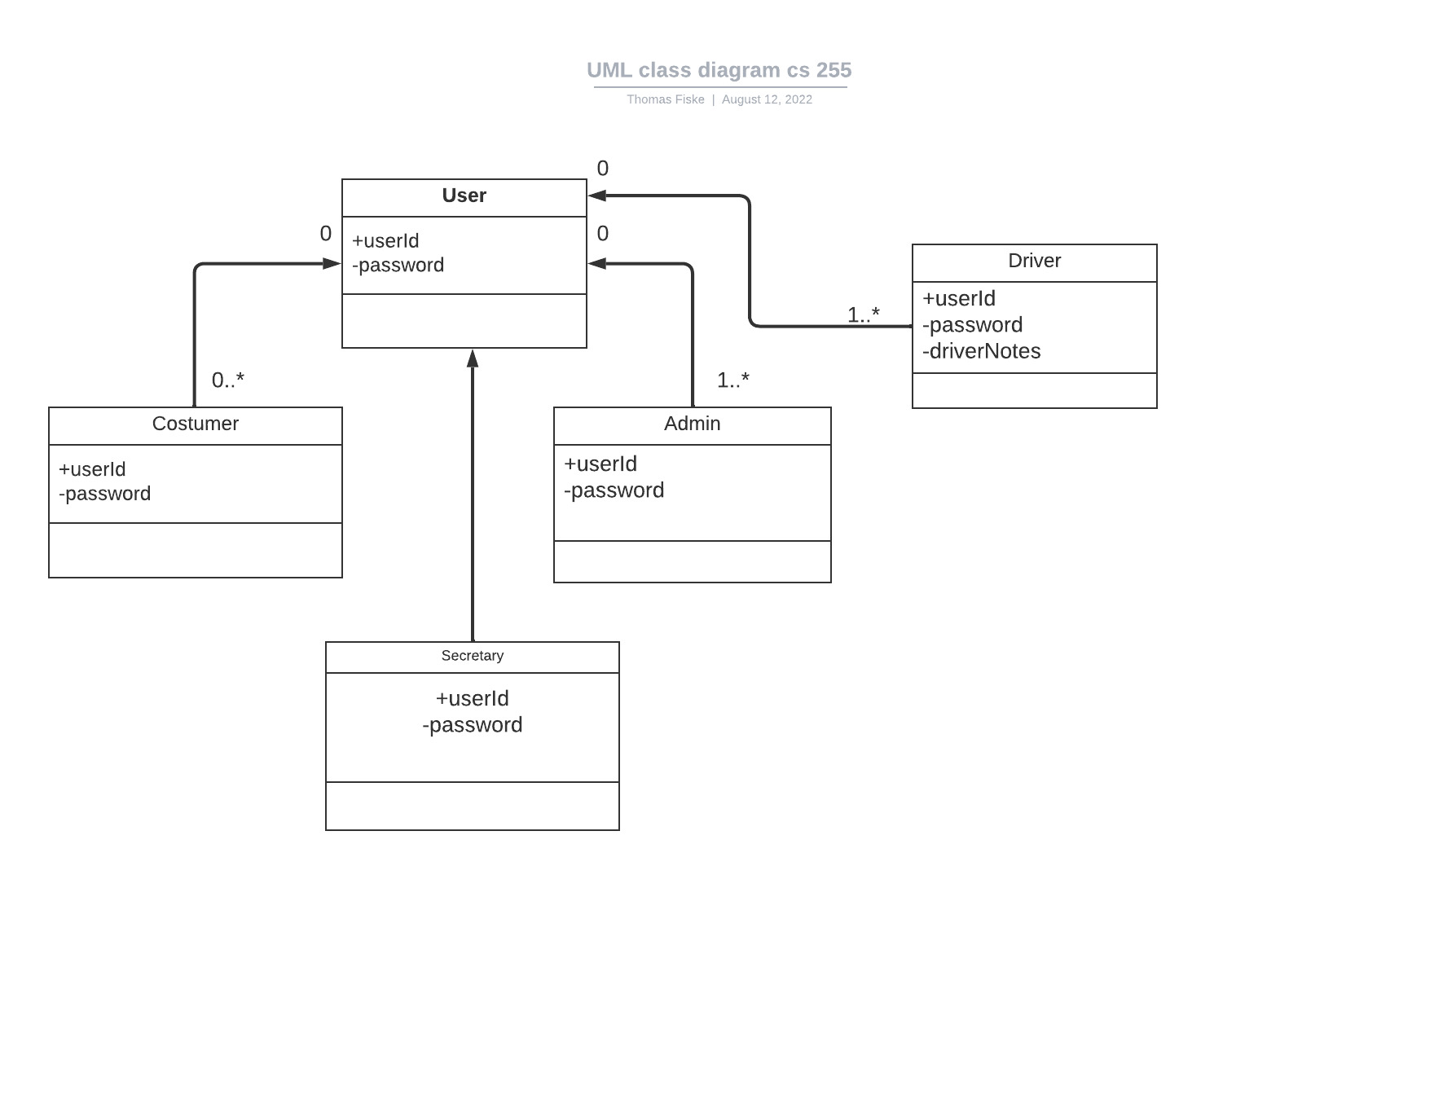

## Technical Requirements

The DriverPass application will need to maintain availability at all times. This ensured that the costumer is able to use the application and do business with the company. The system will be cloud based so this means that the server will be able to maintain this requirement. The system will also need to be able to store user data, appointment data, and more. In order to do this the system will need a database where it can store this information and be able to use it when needed. The admin and secretary will need to be able to cancel/modify appointments. The admin will also need to be able to reset user passwords if need be. They will both need the tools in order to be able to carry out these functions.